**Lab Midterm**

**OOSE**

**Name: Hanzla Nouman**

**Reg# FA21-BSE-015**

**Submitted to: Mukhtiyar Zamin**

# Use Case 15: Pay Bill (Customer)

## Main Success Scenario

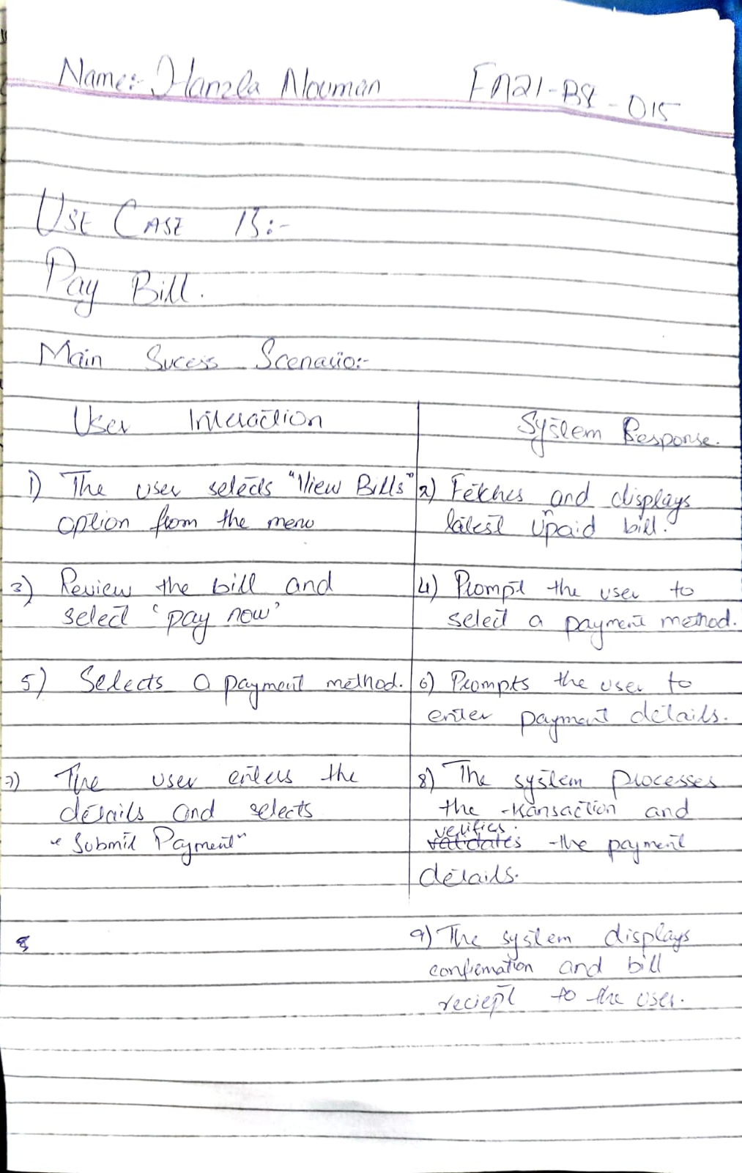

## System Sequence Diagram:

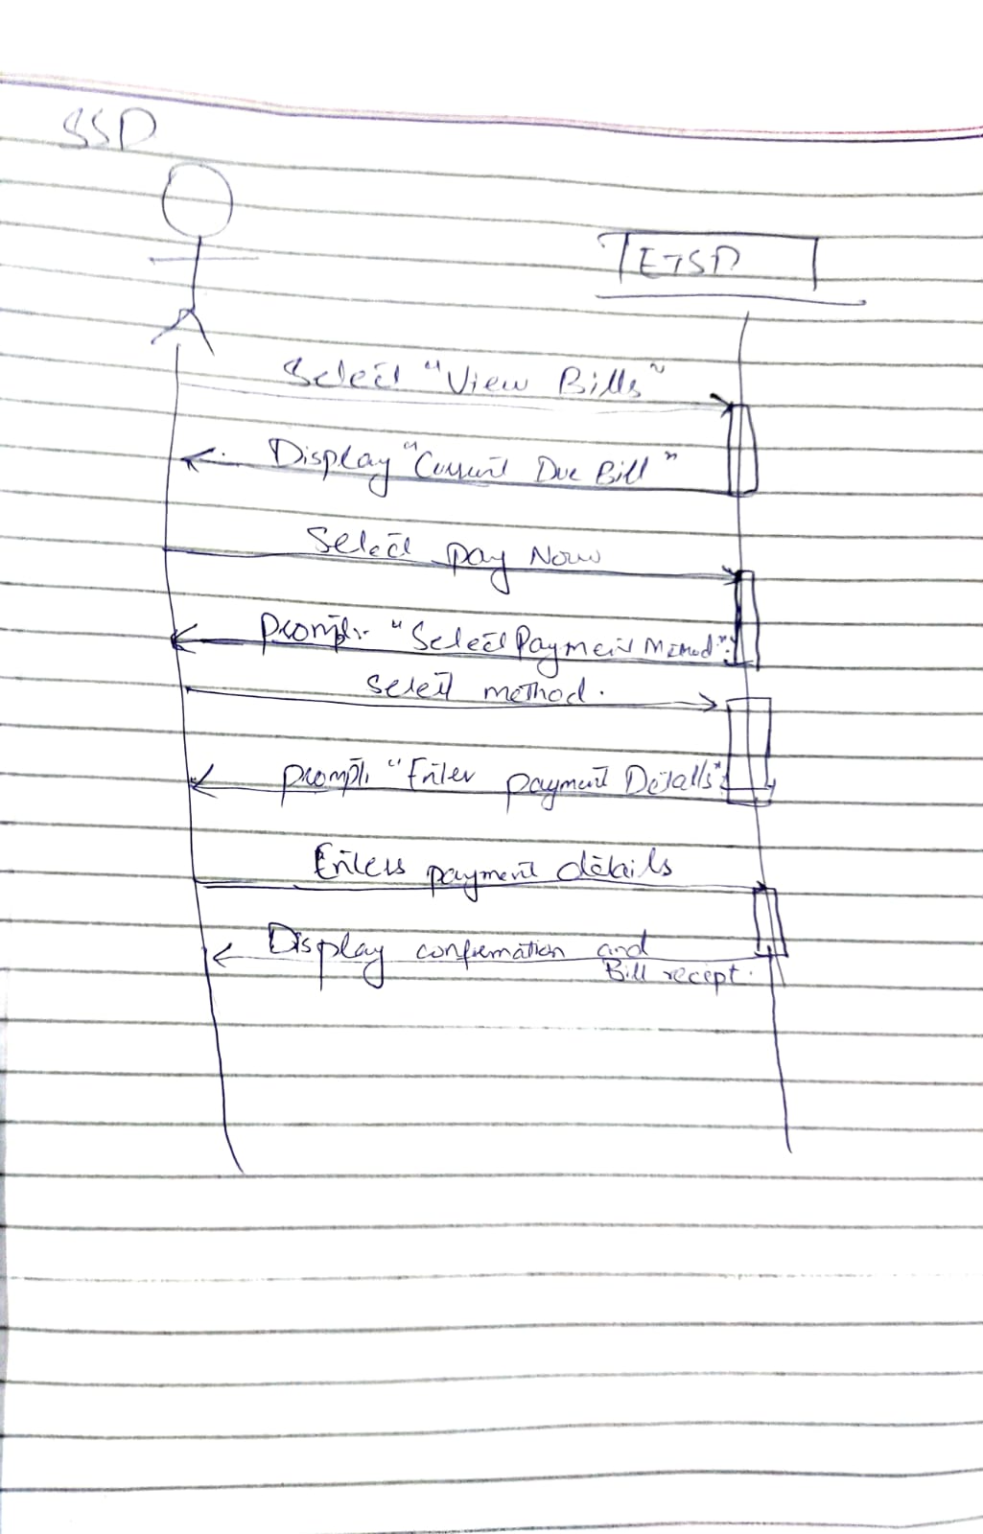

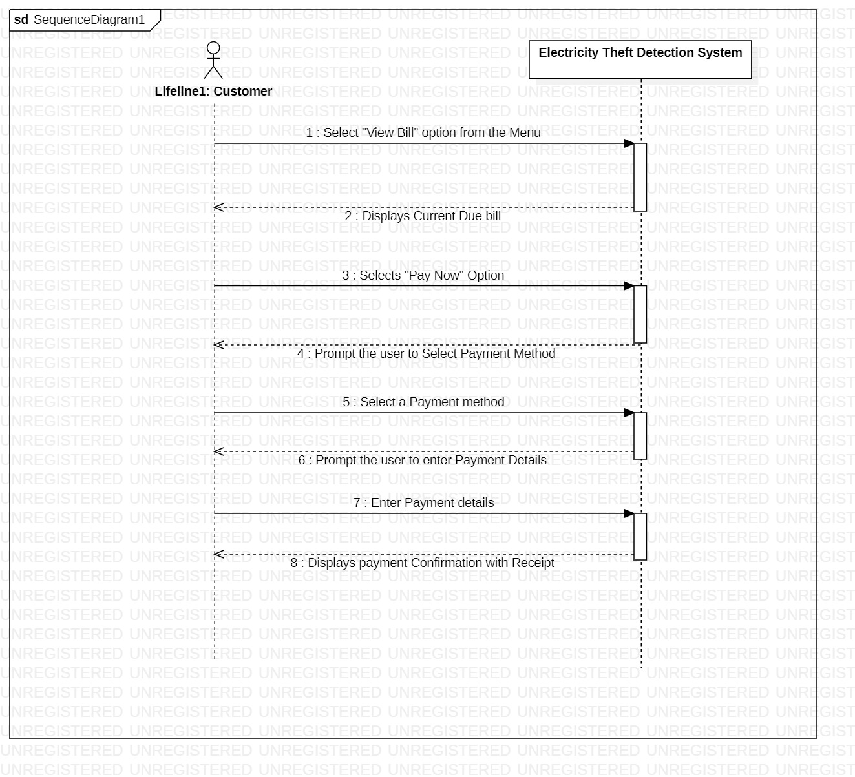

## Prototypes:

### Menu

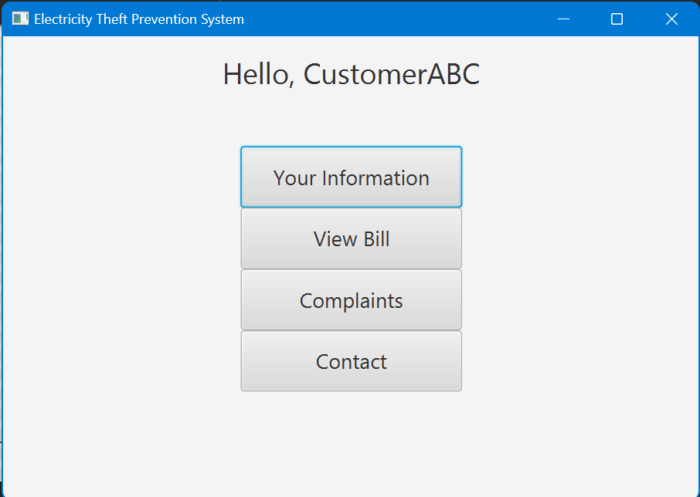

### Bill

### Payment Method and Details:

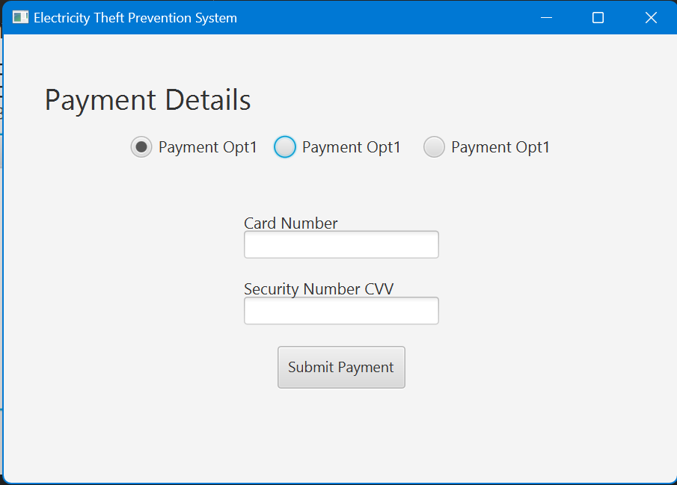

### Submit Confirmation

